DBT Centre of Vancouver presents:
The New DBT Skills –
Part 1: Mindfulness and Distress Tolerance
PRESENTED BY: ALEX CHAPMAN, Ph.D.
JOHN WAGNER, Ph.D.
FRIDAY, MAY 6TH, 2016 9 AM – 4:30 PM
Italian Cultural Centre; Trattoria Hall
3075 Slocan St Vancouver BC
ABOUT THE WORKSHOP
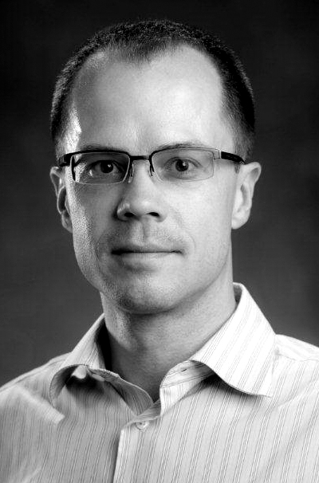
The publication of the 2nd edition of Dr. Marsha Linehan’s DBT Skills Training Manual in 2015 greatly expanded the skills available for assisting clients struggling with a range of psychological problems. The second edition is more than 4 times the length of the first and includes a booklet of new handouts. This special 2-part training will explore many of the new DBT skills. Some of the topics will include ways to deepen clients' (and clinicians') understanding of mindfulness, strategies for building new relationships and ending destructive ones, methods to move forward in valued directions in life, problem-solving skills, and strategies for use in helping clients better manage addictions.
Part one of this workshop will focus on the new mindfulness and distress tolerance skills. In the area of mindfulness skills, the workshop will provide guidance on how to understand and address mindfulness from a spiritual perspective, how to use mindfulness to increase compassion and wisdom, and how to walk the middle path by balancing "being mind" with "doing mind". Some of the newer distress tolerance skills include effective methods for reducing extreme emotions quickly and a variety of techniques for working with addictions.
By the end of this training, participants should be able to:
- Identify at least 5 new ways to practice mindfulness.
- Better explain mindfulness from a spiritual perspective.
- Identify the role of Being Mind and Doing Mind in achieving better life balance.
- Describe new methods for reducing intense emotions easily.
- Explain at least 4 additional skills to overcome addictions.
RECOMMENDED READING
- Linehan, M. M. (2015). DBT skills training manual. New York: Guilford.
- Linehan, M., M. (2015). DBT skills training handouts and worksheets. New York: Guilford.
WHO SHOULD ATTEND
This workshop is intended for psychologists, social workers, mental health counselors, and other mental health professionals who have already had exposure to the DBT skills covered in the first edition of Dr. Linehan’s Skills Training Manual for Treating Borderline Personality Disorder. While some of these new strategies can be used independently of the previous skills, a good working knowledge of them is important for successfully incorporating the new skills into your practice.
Part 2 of this training—Interpersonal Effectiveness and Emotion Regulation—will be offered in the Fall of 2016.
ABOUT THE SPEAKERS
Dr. Alex Chapman,
R. Psych., is the President of the DBT Centre and Coordinator of the Clinical Science area in the Department of Psychology at Simon Fraser University (SFU). Full bio.
Dr. John Wagner,
R. Psych., is the Director of the DBT Centre of Vancouver and an Adjunct Professor in the Department of Psychology at the University of British Columbia. Full bio.
TO REGISTER
- Online: dbtvancouver.com/workshops
- Fax form (see page 2) to: 604-569-1230
- Mail form (see page 2) to:
DBT Centre of Vancouver
1040-1200 Burrard St Vancouver BC V6Z 2C7
- For more information, call: 604-569-1156
The DBT Centre of Vancouver is approved by the Canadian Psychological Association to offer continuing education for psychologists. The DBT Centre of Vancouver maintains responsibility for the program
ELIGIBLE FOR 6 CE CREDITS

Registration for DBT Centre of Vancouver May 2016 Workshop
Friday, May 6th, 2016 9:00am – 4:30pm / Italian Cultural Centre 3075 Slocan St Vancouver BC
Registration Fee (registration closes April 29th)
Early Bird (January 11^{h} –March 31st)
Full-Time Student * $104.50 + $5.23 (GST) = $109.73
Professional $198+ $9.90 (GST) = $207.90
Regular Registration (April 1st – April 29th)
Full-Time Student * $115.50 + $5.78 (GST) = $121.28
Professional $225.50 + $11.28 (GST) = $236.78
Workshop fees include: handouts, morning snack, lunch, afternoon snack and CE certificate.
* To receive the student rate, we require an email or fax confirmation from your supervisor or university department official (e.g., chair of the graduate program, chair of the department) of your student status. Your registration will not be processed without this confirmation of student status.

to register:
Cancellation Policy: DBTCV will provide refunds up to 10 days prior to a schedule workshop.
Refunds will not be provided after April 26th, 2016

Refunds are subject to a $50 administrative fee.
1. Online at www.dbtvancouver.com/workshops
2. Or mail, fax, or email this page to:
DBT Centre of Vancouver
Suite 1040, 1200 Burrard St
Vancouver BC V6Z 2C7
Fax: 604.569.1230 PH: 604-569-1156
Email: info@dbtvancouver.com
PERSONAL INFORMATION (please type**)
Name:
Street address:
City: |  |  |  | Prov./State: |  | Postal Code/Zip:
Phone: |  |  |  | Email:
☐Yes, please add me to your mailing list.
(DBT Centre sends out periodic emails regarding upcoming workshops We will not sell your information to any third parties.)
☐I require a gluten-free lunch |  |  | ☐I have other dietary needs:
PAYMENT INFORMATION (please type**)
I am paying by: ☐Cheque (Make payable to DBT Centre of Vancouver ☐Credit Card (fill information below)
I am paying for:
☐ Early Bird Professional $207.90 ☐ Early Bird Student (include status of student confirmation) $109.73
☐ Regular Professional $236.78 ☐ Regular Student (include status of student confirmation) $121.28 Registration will not be processed without payment.
If you do not receive an email within 1 -2 business days, please email info@dbtvancouver.com
Name on credit card:
Credit card #: |  | Exp. date: /
I hereby sign and give the DBT Centre of Vancouver permission to charge $ to my credit card. The DBT Centre of Vancouver protects client confidentiality and will not divulge or sell this information.
☐I have read and understand the cancellation policy.
Signature :
(Digital signature or initials accepted.)
** May have some difficulties on MAC/Apple software

