DBT Centre of Vancouver presents:
INTRO TO DIALECTICAL BEHAVIOUR THERAPY
A 12 – WEEK COURSE
FRIDAYS , February 19th – May 13th, 2016
9am – 12pm
DBT Centre of Vancouver
#1040 -1200 Burrard St Vancouver BC
ABOUT THE WORKSHOP
The DBT Centre of Vancouver is pleased to offer a 12-week course to mental health professionals seeking to learn about Dialectical Behaviour Therapy (DBT). The most widely researched treatment for problems characteristic of Borderline Personality Disorder (BPD), DBT is a comprehensive psychological treatment that assists persons struggling with complex problems, including recurrent suicidality, self-harm, and problems with emotion regulation.
This course, offered as part of an ongoing consultation and training program at the DBT Centre, covers all aspects of DBT including individual therapy, skills training, telephone consultation, and consultation teams. The teaching methods include didactics, demonstration/practice, audio and video review, and worksheets. Participants will be assigned weekly readings and between-class activities.
ABOUT THE INSTRUCTORS
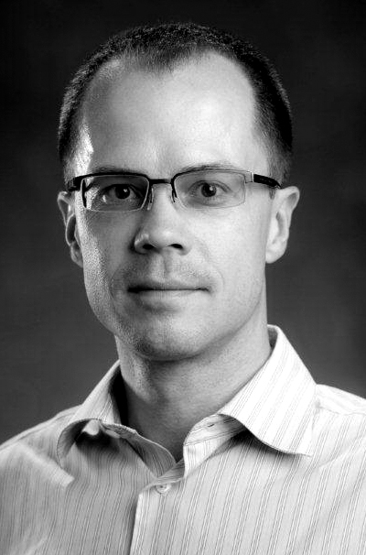
Alexander Chapman, Ph.D., is a Registered Psychologist, President of the DBT Centre of Vancouver, and an Associate Professor in the Department of Psychology at Simon Fraser University. He has written many publications on DBT & BPD.
John Wagner, Ph.D., is a Registered Psychologist, Director of the DBT Centre of Vancouver, and an Adjunct Professor at the University of British Columbia. He regularly provides consultation and training to area providers.
Both completed fellowships working with Dr. Marsha Linehan (the developer of the treatment). Their full bios can be found at www.dbtvancouver.com

TOPICS COVERED
- Research on BPD & DBT
- Dialectical Theory and Strategies
- Commitment Strategies
- Suicidal Risk Assessment and Intervention
- Chain Analysis and Problem-Solving
- Using Reciprocity and Irreverence
- Managing Telephone Consultation
- Applying Change Strategies in DBT: Solution Analysis, Cognitive Modification, Contingency Management, Exposure, & Skills Generalization
- Skills Training in DBT: Mindfulness, Emotional Regulation, Distress Tolerance, & Interpersonal Effectiveness
- Case Management & Consultation Teams

WHO CAN REGISTER
Mental health professionals (with a minimum of a master’s degree in a mental health field or graduate students in an applicable program) seeking to gain a better understanding of DBT and useful clinical tools to use in practice are encouraged to register.
The DBT Centre of Vancouver is approved by the Canadian Psychological Association as a provider of continuing education activities, and participants are eligible for 36 CE credits

TO REGISTER
- Online: http://dbtvancouver.com/classes
- Fax form to: 604-569-1230
- Mail form to: DBT Centre of Vancouver
1040-1200 Burrard St Vancouver BC V67 2C7
- For more information, call: 604-569-1156

Registration for DBT Centre of Vancouver
Intro to DBT course
Fridays, February 19th – May 13th, 2016 9:00am – 12:00pm
(No class March 25th)
Registration Fee
Full-Time Student * $1160 + $58 (GST) = $1218
Professional $1600 + $80 (GST) = $1680
* To receive the student rate, we require an email or fax confirmation from your supervisor or university department official (e.g., chair of the graduate program, chair of the department) of your student status. Your registration will not be processed without this confirmation of student status.

to register:
1a.) Online: dbtvancouver.com/workshops/12weekDBT/
Cancellation Policy: DBTCV will provide refunds up to 14 days prior to a schedule workshop. Refunds will not be provided after February 5th, 2016.

Refunds are subject to a $150 administrative fee.
1b.) Or mail, fax, or email this page to:
DBT Centre of Vancouver
Suite 1040, 1200 Burrard St
Vancouver BC V6Z 2C7
Fax: 604.569.1230 PH: 604-569-1156
Email: info@dbtvancouver.com

2. Please email a current resume and a brief cover letter, indicating 1.) How you heard about the course and 2.) What is your motivation for taking the course? How will you be using the material covered? Please email to Jen Gerullis at info@dbtvancouver.com
PERSONAL INFORMATION – please type**
Name:
Street address:
City: |  |  | Prov./State: |  | Postal Code/Zip:
Phone: |  |  | Email:
PAYMENT INFORMATION – please type**
I am paying by:
☐Cheque (Mail to DBT Centre of Vancouver Suite 1040, 1200 Burrard St Vancouver BC V6Z 2C7)
☐Credit Card (fill information below)
☐Professional rate: One-time payment $1680
☐Professional rate: Four payments of $420 (At registration, March 4th, April 1st, and May 13th, 2016)
☐Student rate** : Four payments of $304.50 (At registration, March 4th, April 1st, and May 13th, 2016)
Registration will not be processed without payment. You will receive an email confirmation of registration.
Name on credit card:
Credit card #: |  | Exp. date: /
I hereby sign and give the DBT Centre of Vancouver permission to charge $ to my credit card. The DBT Centre of Vancouver protects client confidentiality and will not divulge or sell this information.
Signature: (digital signature or initials acceptable)
** May have difficulties on Apple products/ MAC software

