DBT Centre of Vancouver presents:
RADICALLY OPEN DIALECTICAL BEHAVIOUR THERAPY – A TWO DAY TRAINING
PRESENTED BY TOM LYNCH, Ph.D.
MONDAY, JANUARY 26TH – TUESDAY, JANUARY 27th, 2015
9AM – 4:30 PM
Italian Cultural Centre
3075 Slocan St Vancouver BC
ABOUT THE WORKSHOP Based on 19 years of research, including two NIMH funded trials, Radically Open Dialectical Behaviour Therapy (RO-DBT) is a new treatment targeting over-controlled behaviour (OC). It has been used to treat some of the rigid responses and emotional inhibition thought to underlie many treatment-resistant conditions.
Who is the Treatment for?
Patients who have a diagnosis of Chronic Depression, Treatment-Resistant Anxiety Disorders, Anorexia Nervosa, Avoidant, Paranoid and Obsessive Compulsive Personality Disorders and Autism Spectrum Disorders.
What do these Disorders have in Common?
Self-control, the ability to inhibit competing urges, impulses, or behaviours is highly valued by most societies. However, excessive self-control has been linked to social isolation, poor interpersonal functioning, hyper perfectionism, rigidity, risk aversion, lack of emotional expression, and the development of severe and difficult-to-treat mental health problems, such as anorexia nervosa, obsessive compulsive personality disorder and refractory depression.
RO-DBT posits emotional loneliness as the core problem underlying maladaptive overcontrol. Heightened threat sensitivity and diminished reward sensitivity are hypothesized to transact with early family experiences emphasizing “mistakes intolerable” and “self-control imperative” to produce overcontrolled coping. A novel thesis linking the communicative functions of emotional expression to the formation of close social bonds will be introduced, as well as new skills emphasizing receptivity, self-enquiry and flexible responding. New approaches to activate a neurobiologically-based social-safety system, signal cooperation, enhance forgiveness, and change envy/bitterness will be introduced; using videos and role play.
For more information on RO-DBT go to www.radicallyopen.net
ABOUT THE SPEAKER Professor Lynch is an international expert on personality disorders and is Director of the Emotion and Personality Bio-behavioural Laboratory in the School of Psychology at the University of Southampton. He is a world-leading researcher and treatment developer. He is currently the Chief Investigator on PROJECT REFRAMED, an NHS multi-centre Randomised Controlled Trial investigating Radical Openness for Treatment-Resistant Depression.
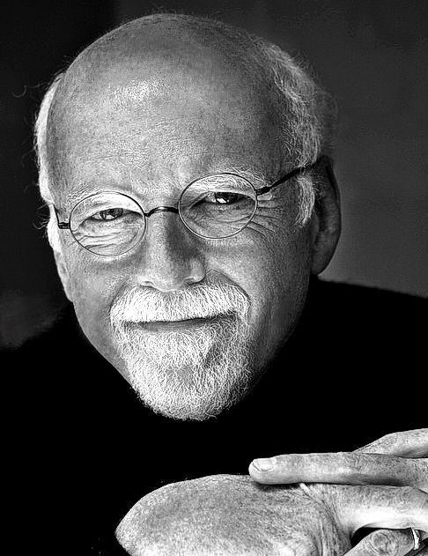
OBJECTIVES
- Overview of treatment structure
- Recognize a new biosocial theory for OC and new RO-DBT treatment strategies designed to enhance willingness for self- inquiry and flexible responding
- Identify new skills designed to enhance intimate relationships and vulnerable expression of emotion, learn from critical feedback, and enhance loving- kindness-forgiveness
- Identify a novel treatment mechanism positing open expression = trust = social connectedness
- Examples of strategies designed to improve pro-social cooperative signalling via activation of the parasympathetic nervous system’s social-safety system

PREVIOUS EXPERIENCE OR TRAINING IN STANDARD DBT IS NOT REQUIRED

TO REGISTER
- Online: http://dbtvancouver.com/workshops/
- Fax form to: 604-569-1230
- Mail form to: DBT Centre of Vancouver
1040-1200 Burrard St Vancouver BC V67 2C7
- For more information, call: 604-569-1156

ELIGIBLE FOR 12 CE CREDITS

Registration for DBT Centre of Vancouver JANUARY 2015 Workshop
Monday, January 26th – Tuesday, January 27th, 2015 9:00am – 4:30pm
Italian Cultural Centre 3075 Slocan St Vancouver BC
For more information visit http://dbtvancouver.com/workshops/2015jan
Registration Fee (registration closes January 19th)
Early Bird (October 14th – December 29th)
Full-Time Student * $170 + $8.50 (GST) = $178.50
Professional $320 + $16 (GST) = $336.00
Regular Registration (December 30th – January 16th)
Full-Time Student * $190 + $9.50 (GST) = $199.50
Professional $370 + $18.50 (GST) = $388.50
Workshop fees include handouts, morning snack, lunch, and afternoon snack and CE certificate.
* To receive the student rate, we require an email or fax confirmation from your supervisor or university department official (e.g., chair of the graduate program, chair of the department) of your student status. Your registration will not be processed without this confirmation of student status.

to register:
Cancellation Policy: DBTCV will provide refunds up to 14 days prior to a schedule workshop. Refunds will not be provided after January 12th, 2014.

Refunds are subject to a $50 administrative fee.
1. Online at www.dbtvancouver.com/workshops
2. Or mail, fax, or email this page to:
DBT Centre of Vancouver
Suite 1040, 1200 Burrard St
Vancouver BC V6Z 2C7
Fax: 604.569.1230 PH: 604-569-1156
Email: info@dbtvancouver.com
PERSONAL INFORMATION
Name:
Street address:
City: |  |  |  | Prov./State: |  | Postal Code/Zip:
Phone: |  |  |  | Email:
☐Yes, please add me to your mailing list. (DBT Centre sends out periodic emails regarding upcoming workshops We will not sell your information to any third parties.)
☐I require a gluten-free lunch |  |  | ☐I have other dietary needs:
PAYMENT INFORMATION
I am paying by:
☐Cheque (Mail to DBT Centre of Vancouver Suite 1040, 1200 Burrard St Vancouver BC V6Z 2C7)
☐Credit Card (fill information below)
Registration will not be processed without payment. You will receive an email confirmation of registration.
Name on credit card:
Credit card #: |  | Exp. date: /
I hereby sign and give the DBT Centre of Vancouver permission to charge $ to my credit card. The DBT Centre of Vancouver protects client confidentiality and will not divulge or sell this information.
Signature:

